Conversations about Culture: Video & Lesson Plan
According to Gray (2005), “A dialogical approach is preferred wherein we have conversations about our cultures – and their differences and similarities – which we approach with an attitude of humility and curiosity – with the mind of a learner rather than an expert
(despite our considerable knowledge about social work)” (p. 237).

Conversations About Culture: The Importance of Cultural Humility (Video)

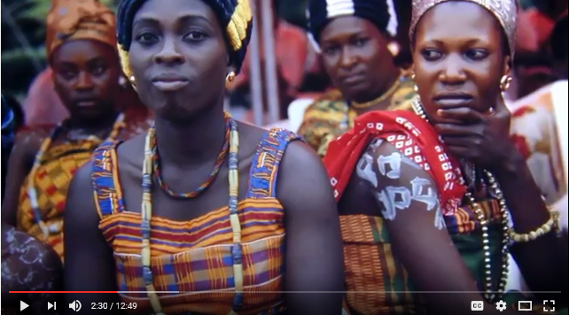
https://youtu.be/cVmOXVIF8wc (12:49)
This video defines the concept of cultural humility and highlights related components. Cultural humility is defined as an ongoing process of self- reflection and self-critique. It entails working collaboratively with clients, and embracing difference. Students, faculty and practitioners reflect on the role of cultural humility in their work and share their insights.

Lesson Plan: Cultural Humility and Cross-Cultural Competence
This online learning module is designed to facilitate skills for effective cross cultural communication and collaboration. The very important concept of cultural humility is a central focus. Cultural humility entails acknowledging difference, and positioning ourselves as people interested in learning and understanding. Cultural humility is particularly relevant to a trauma-informed, human-rights-based approach to social work practice; it underscores the dignity and value of the individual and empowers the client as expert in their experience.
This module can be used as a resource for educators, students planning to study abroad or engage in international field work, faculty engaged in cross-cultural research and partnerships, human service practitioners, educators, and any other interested parties. It can be incorporated into a range of social work courses including those dealing with policy and practice.
Because the process of self-reflection is so important for the development of cultural humility, sample reflection exercises are provided.
Learning Objectives
- Define the concept of cultural humility
- Discuss the difference between cultural competence and cultural humility
- Highlight the role cultural humility plays in social work practice
- Explore the dynamics of difference
- Reflect on the knowledge, skills, and attitudes which are associated with becoming culturally self-aware and valuing diversity.
- Increase awareness of unconscious cultural stereotypes, and the impact of these on service recipients

Materials for the lesson are organized as follows:
- Lecture Sources – Videos; Readings
- Reflective Exercises
- Self-Assessment Tools
- Additional Resources – Interactive Resources
- References

Instructors may want to give a pre-test and post-test. Alternately, students can be asked to demonstrate learning through participation in role play or self-reflection exercises.

Lecture Sources

Richards-Desai, S., Lewis, L. (2016) Conversations about Culture: Conversations About Culture: The Importance of Cultural Humility [Video file]. Retrieved from https://youtu.be/cVmOXVIF8wc.

Elze, D. (2016, June 8). Introduction to Cultural Competence [Video file]. Retrieved from https://youtu.be/-4uhbv9hWnI.

Elze, D. (2016, June 8). Attribution Theory: Strategies for Engaging Patients/Clients and Avoiding Inaccurate Assumptions [Video file]. Retrieved from https://youtu.be/mOTac0bS_2A.

Reflective Exercises

After viewing the video, “The Importance of Cultural Humility”, respond to the following questions:

Describe how personal narrative and self-reflection are beneficial in developing cultural humility.
One theme in the module is a contrast between cultural competence and cultural humility. In your own words, describe these concepts and how you see them relating to one another.
How do you react to the idea of continually learning about your clients’ backgrounds and the systemic factors that oppress populations? How is this reflected in social work professional development?
Think about an example from field in which you became aware of internal reactions to difference. Pay attention to what you felt and did. Has the module shared information that could help to process some of these events?
There are different voices and experiences represented in the module. Which phrases or thoughts stood out to you? Is there anything you would say reflects your own ideas? What would you disagree with?
Based on your own personal and professional experiences, respond to the following questions:

Describe a scenario in which you (or someone that you know) experienced cultural humility (or lack thereof) in an interpersonal exchange. Consider the cultural context in which this occurred, and reflect on and evaluate your response.
What types of actions or competencies reveal cultural humility to you?
One way that I can recognize and develop cultural humility in myself is to….
One time that I witnessed/experienced genuine cultural humility was….
Cultural humility can directly benefit me, my colleagues, and clients, because….
A number of skills contribute to the development of cultural competency. These include the ability to: 1) articulate one’s perspective respectfully and clearly; 2) question one’s own perspective; 3) demonstrate awareness of one’s own biases; 4) manage personal biases and stereotypes; and, 5) personalize observations and rephrase using “I” statements.

Consider the fourteen personal competencies identified by Hogan (2007). Rate yourself on a scale of 1 (low) to 5 (high) in each of these areas. Add up the points: 617-70=high; 51-60=moderate, 0-50 needs more practice.
- Be nonjudgmental (we have a common tendency to judge those we perceive as different.)
- Be flexible (adjust and readjust)
- Be resourceful (be prepared, look for alternatives)
- Personalize observations (recognize that one’s personal perceptions, attitudes, and beliefs may not be shared)
- Pay attention to thoughts and feelings
- Listen carefully
- Observe attentively
- Assume complexity
- Tolerate the stress of uncertainty
- Have patience
- Manage personal biases and stereotypes
- Keep a sense of humor
- Show respect
- Show empathy

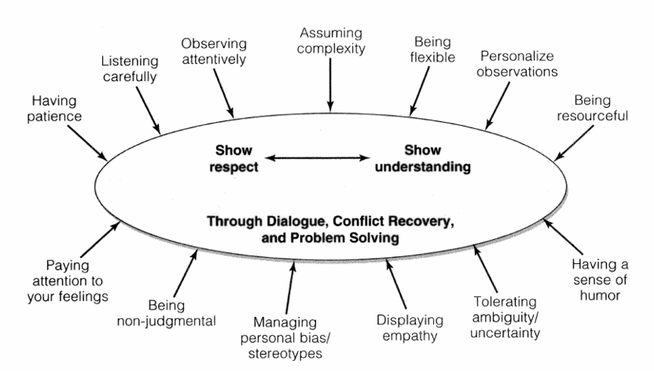

Describe your personal reaction to this self-assessment exercise.
How will you will focus your own personal and professional development to develop these skills further?
(Hogan, 2013)

Self-Assessment Tools

Cultural Competence Self-Test http://www.healthystartpinellas.org/pdf/Self_Assess_5.pdf
Diversity Quiz http://www.diversitycentral.com/tools_and_resources/diversityquiz.php
Test Yourself for Hidden Bias http://www.tolerance.org/activity/test-yourself-hidden-bias

Additional Resources

Fisher-Borne, M., Cain, J. M. & Martin, S. L. (2015). From mastery to accountability: Cultural humility as an alternative to cultural competence. Social Work Education, 34(2), 165-181.
Retrieved from http://dx.doi.org/10.1080/02615479.2014.977244 This article is not available. I suggest getting it and putting it in a UB Learns site for the students. I think resources in a reference list should be available to the students.

Hogan, M. (2013). Four skills of cultural diversity competence: A process for understanding and practice (4th Ed.). Belmont, CA: Thomson-Brooks/Cole.

National Association of Social Workers (n.d.). Standards and indicators for cultural competence in social work practice, Retrieved from http://www.socialworkers.org/practice/standards/Standards_and_Indicators_for_Cultural_Competence.asp.

Yan, M. C. (2008). Exploring cultural tensions in cross-cultural social work practice. Social Work. Vol 53 Issue 4, 317-328. Retrieved from https://www.researchgate.net/profile/Miu_Chung_Yan/publication/23318354_Exploring_cultural_tensions_in_cross-cultural_social_work_practice/links/55b6522f08aed621de032fdf.pdf

Web Resources
Race: The power of an Illusion (series by PBS-racial identities and the history of race in the US)
http://www.pbs.org/race/000_General/000_00-Home.htm

Background Readings “Society” http://www.pbs.org/race/000_About/002_04-background-03.htm

Interactive Sites
What is Race? http://www.pbs.org/race/001_WhatIsRace/001_00-home.htm
Sorting People http://www.pbs.org/race/002_SortingPeople/002_00-home.htm
Race Timeline http://www.pbs.org/race/003_RaceTimeline/003_00-home.htm
Human Diversity http://www.pbs.org/race/004_HumanDiversity/004_00-home.htm
Me, My Race & I http://www.pbs.org/race/005_MeMyRaceAndI/005_00-home.htm
Where Race Lives http://www.pbs.org/race/006_WhereRaceLives/006_00-home.htm

References
Gray, M. (2005). Dilemmas of international social work: Paradoxical processes in indigenization, universalism and imperialism. International Journal of Social Welfare, 14, 231-238.

Hogan, M. (2013). Four skills of cultural diversity competence: A process for understanding and practice (4th Ed.). Belmont, CA: Thomson-Brooks/Cole. Adapted with permission.

Acknowledgement

This lesson plan and module was created by Sarah Richards-Desai, MSW, in conjunction with Dr. Laura Lewis, assistant dean for global partnerships at University at Buffalo School of Social Work. We hope that this resource assists you in having your own very important conversations about culture.
We would like to express our heartfelt thanks to all those who have helped us in this effort: the colleagues who generously contributed materials and provided advice on resources, the experts in the field who gave permission to include their materials, and the SSW students who provided their perspective. Special thanks to Dr. Mikel Hogan, Dr. Diane Elze, and Dr. Kathleen Kost for the resources they provided and for their input. Special thanks also to Razak Nsor and Annie Bruns, both MSW Students at the time these materials were developed, and to Stephanie Vroman-Goodrich, LMSW, for their contributions.

Authors - Contact Us
Sarah Richards-Desai, MSW; University at Buffalo School of Social Work; scrichar@buffalo.edu
Laura Lewis, PhD, LCSW; University at Buffalo School of Social Work; lalewis@buffalo.edu

